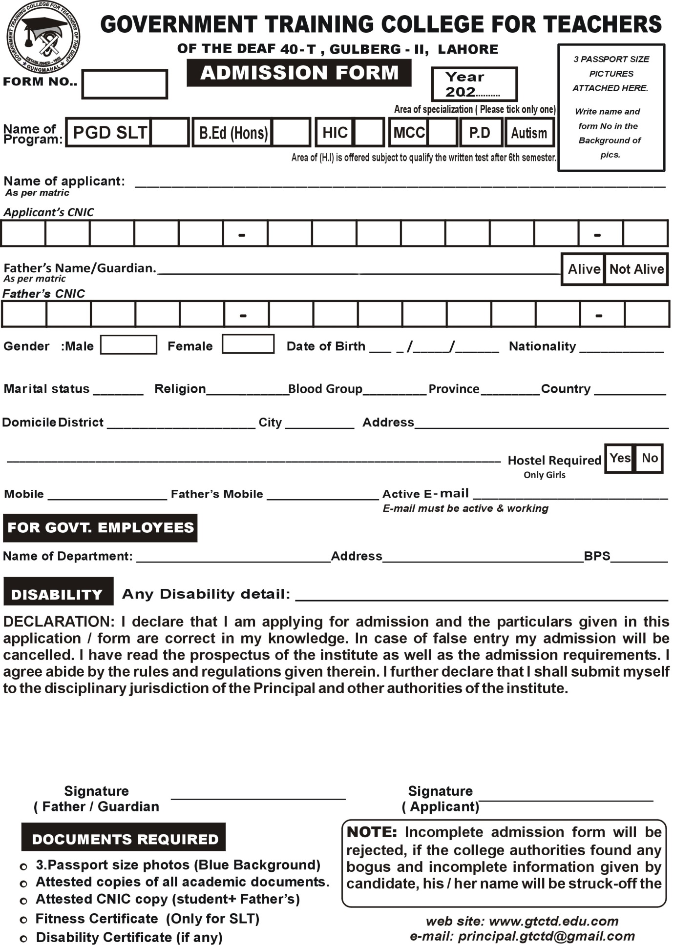

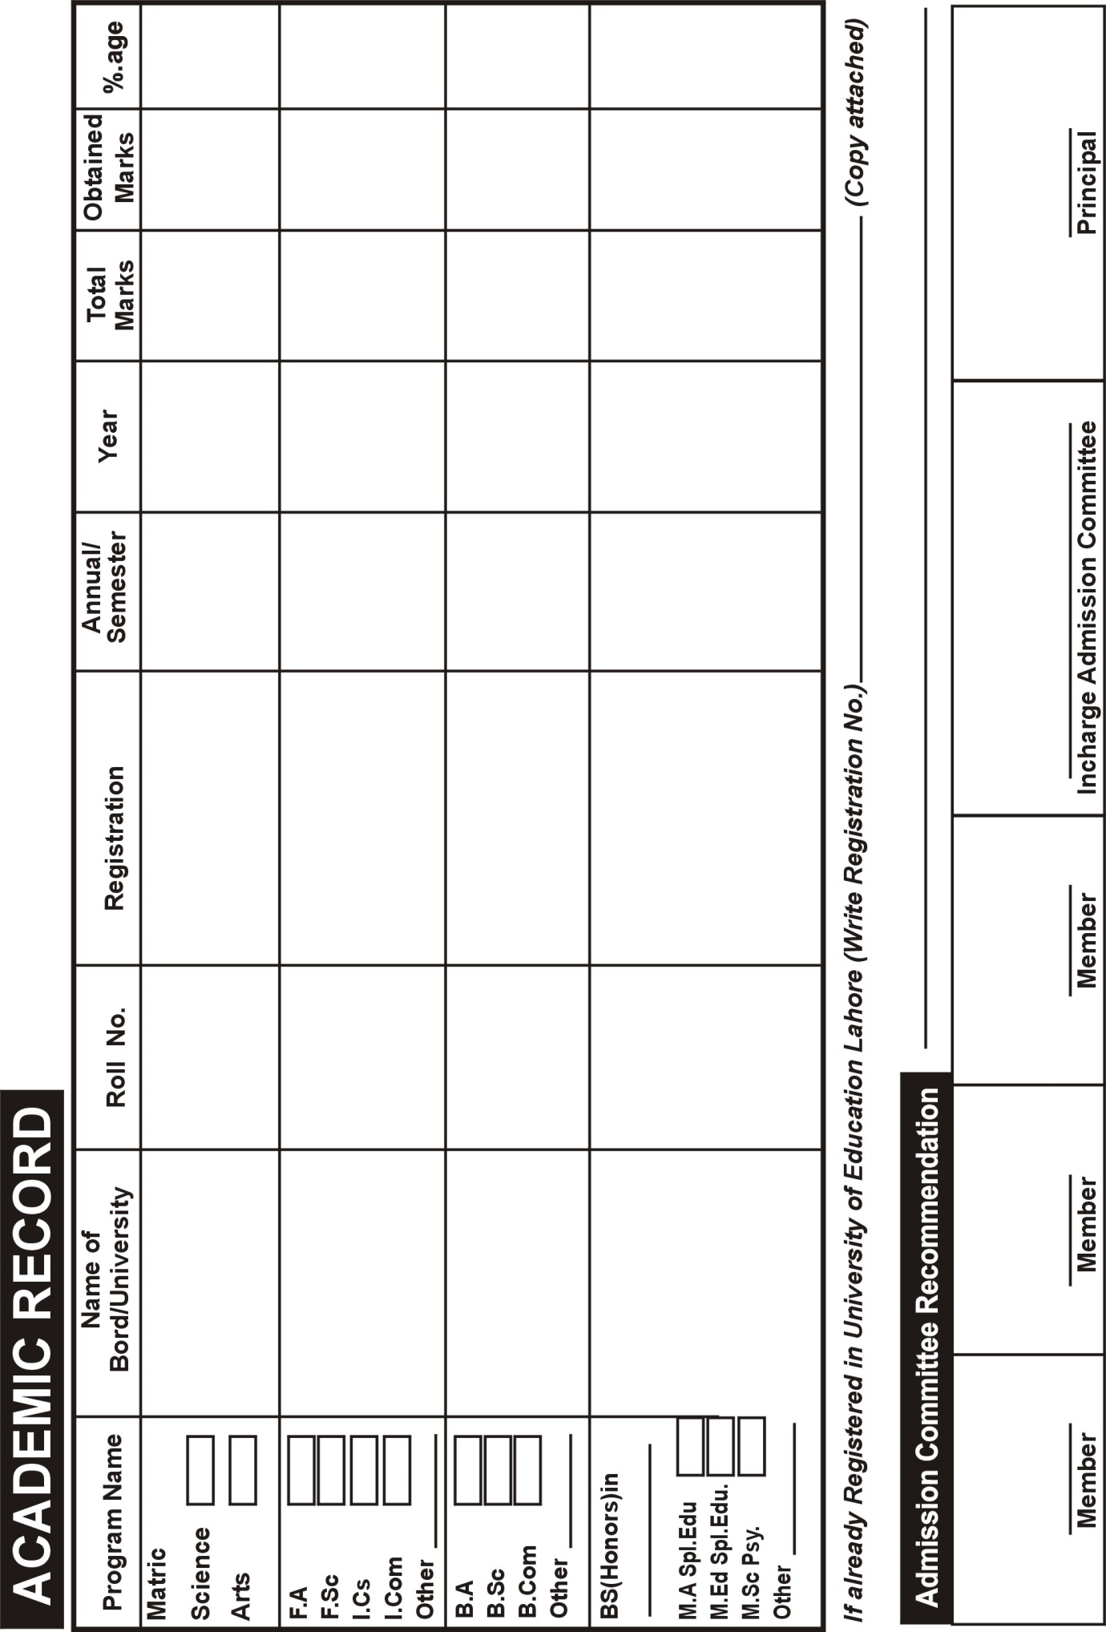

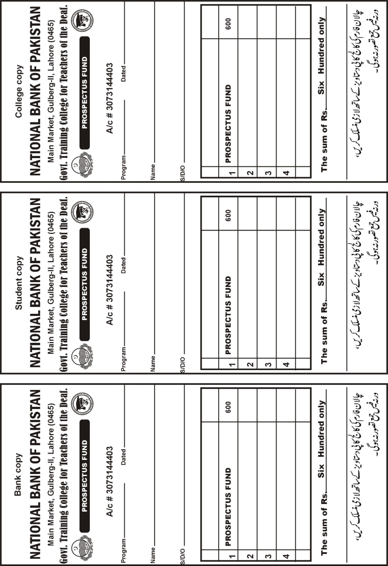

IMPORTANT INSTRUCTIONS:
- Fill Admission form carefully; Bogus/Incorrect/Incomplete information may lead to cancellation of admission.
- Admission form along with mentioned documents should reach this college before last date i.e. 13-10-2023 (Friday).
- Students downloading form from college website will submit challan fee of 600 PKR and college copy of fee deposit will be attached with the form.
- Without college copy it will be assumed that fee is not deposited.

